|  |  |  |
| --- | --- | --- |
| Project | Seize the Day | |
| This document contains basic information about project “Seize the Day” like: executive summary, concept of our system, the analysis of requirements, functional requirements, non-functional requirements. | | Justyna Kubisztal Adam Krupski Michał Szczygieł |



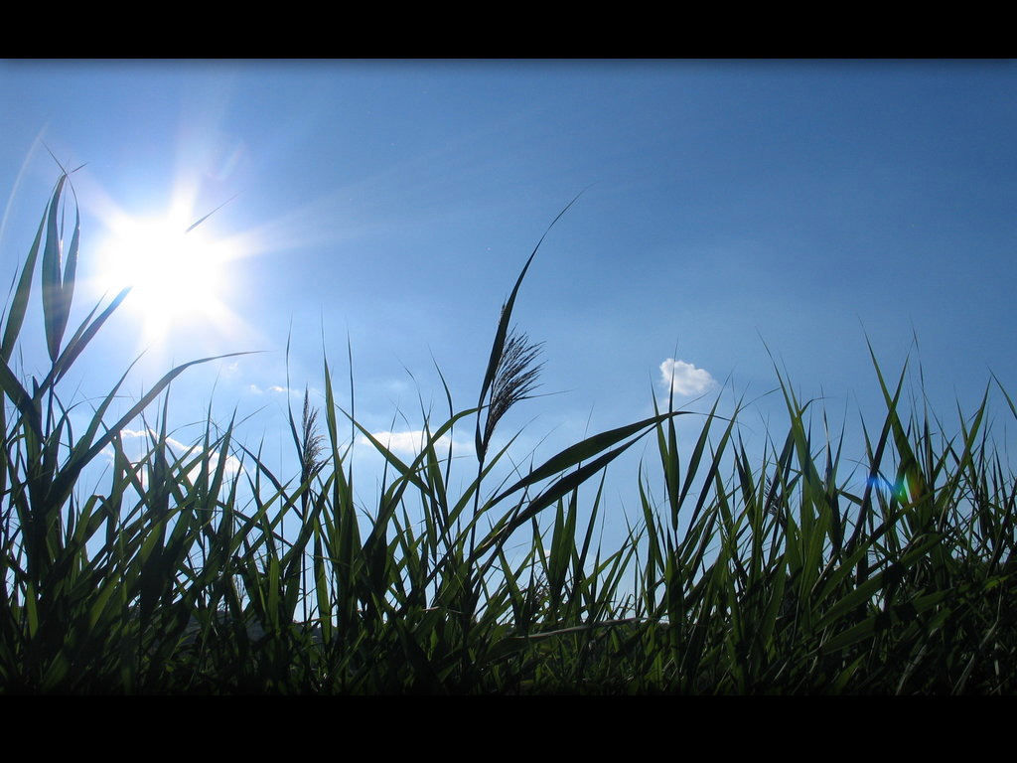

  
table of contents

INTRODUCTION2

USE CASE6

Diagram7

GUI8

Editing removing component9

Setting alarm clock time 10

Time setting 11

TODO list editing12

SYSTEM' INFORMATION FLOW MODEL13

DIAGRAM CLASS CONCEPT14

TIME TABLE15

Time table for Windows Phone15

Time table for Android17

DIFFERENCES BETWEEN PROJECTS19

EXTRAS29

# C:\Users\Michał\Desktop\black.jpgC:\Users\Michał\Desktop\black.jpg C:\Users\Michał\Desktop\black.jpg



INTRODUCTION

9.12.2012

**

Every day during our sleep,   
we don’t think about what will bring tomorrow

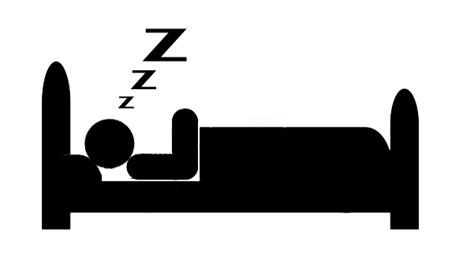

**

And when you wake up, you don’t have any idea what you should do



**

But every day you use your phone like alarm clock.  
How to improve life???

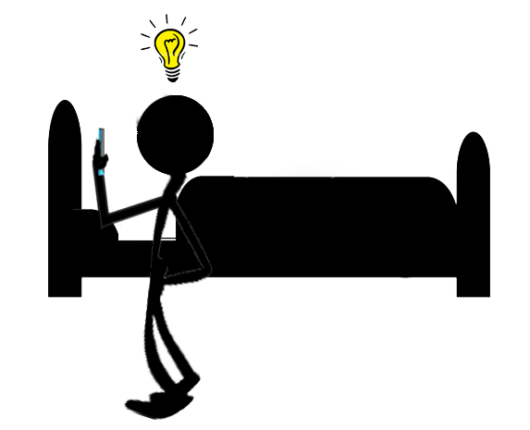

**

Everything in your phone screen:   
weather, tasks to do, how to dress, what’s new in world

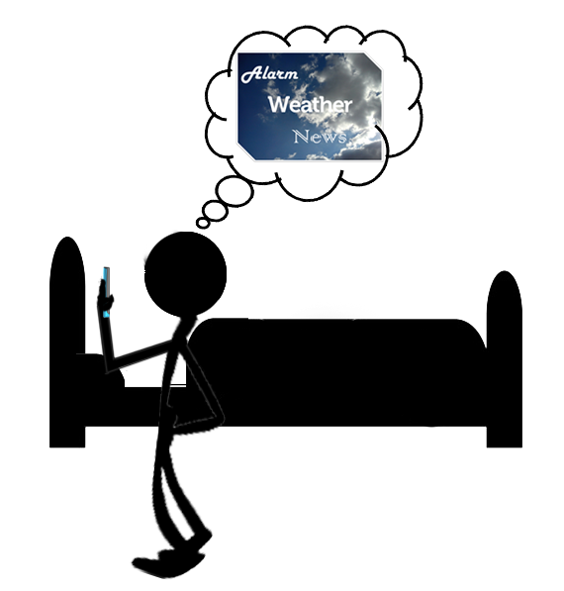





USE CASE

1. Main Form
   1. Adding new component
      1. After pressing (+) button user have possibility(can) to set new component:
         1. Time component:
            1. User can add new alarm time.

User can change alarm time.

* + - * 1. User can remove added alarm time.
        2. User can set sounds for alarm.
      1. Task component:
         1. User can add new task.
         2. User can change task time.

User can change task.

* + - 1. Weather component:
         1. User can see weather.
         2. User can see how to dress.
         3. User can change settings.

Set automatically own location.

Set manually location using geographic position.

Using GPS cords.

Using normal address.

* + - 1. News component:
         1. User can see news.
         2. User can change settings.

User can change category.

User can set amount of showing news.

* + - 1. Aphorisms component:
         1. User can see aphorism.
  1. Remove existing component

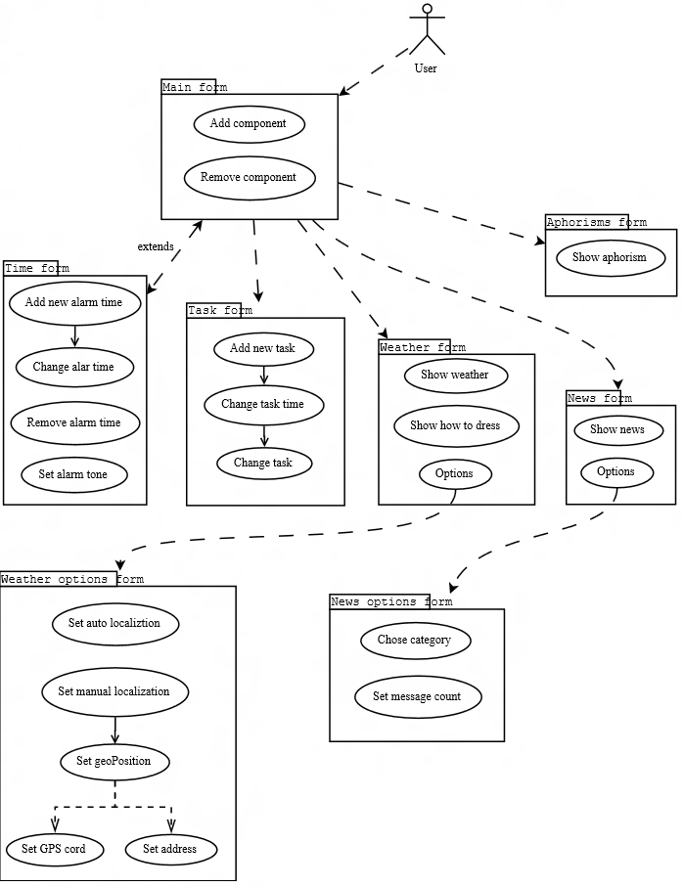





GUI



# Editing removing component

When user clicks on component, two small icons are shown: one for removing   
and one for editing component.

When user chooses icon with trash, the component is removed. If icon with pencil is chosen, new screen is shown with settings of component. Each component has different screen for settings.

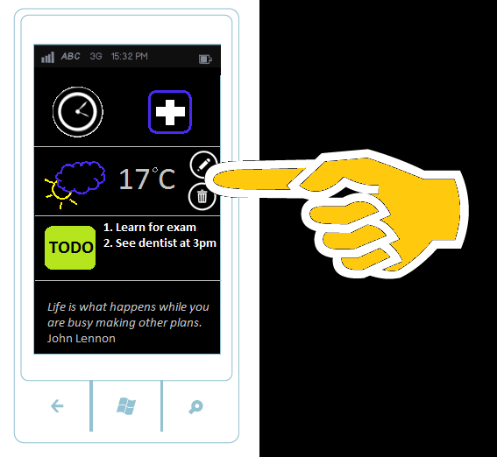

# Setting alarm clock time

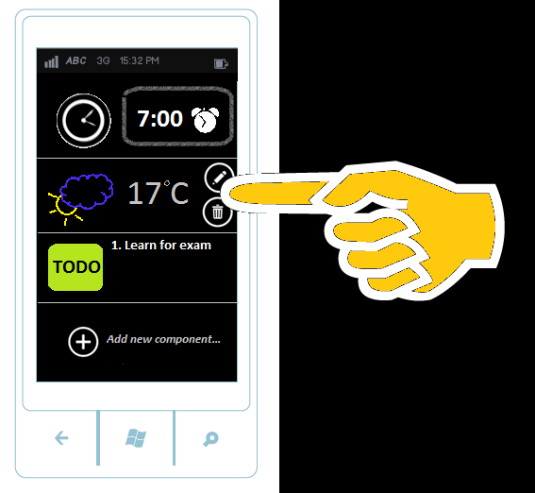

On the bottom of list with component there is an icon for adding new component.   
If pressed, user will be asked which component he want to add.

**

# Time setting

When user press clock or add button, screen with alarm clock is shown. Time can be set here.

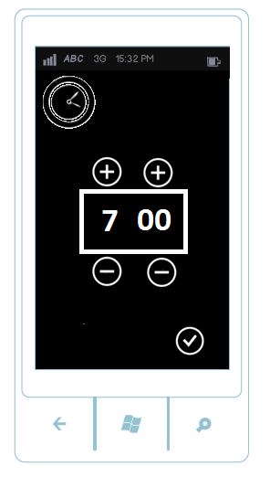

# TODO list editing

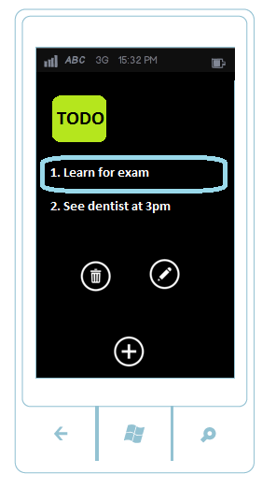

When editing TODO list, screen as above is shown.

When precise task is selected icons/buttons with option of editing and deleting   
are shown.





SYSTEM' INFORMATION FLOW MODEL

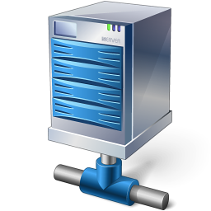

Server 3

Server 2

Server 1



DIAGRAM CLASS

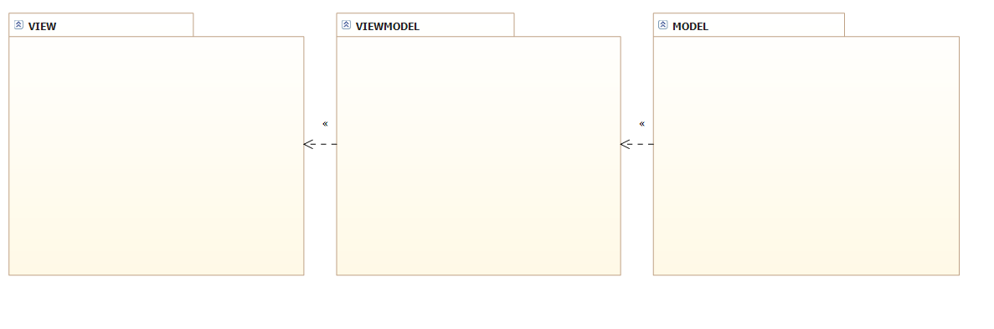

# D:\Studies\Jyväskylän ammattikorkeakoulu\Windows Phone Programming\Project\MPwA and WPP EndProjectDoc\diagrams\xaml.pngC:\Users\Michał\Desktop\black.jpgC:\Users\Michał\Desktop\black.jpgView



TIME TABLE WINDOWS PHONE

|  |  |  |  |  |  |  |
| --- | --- | --- | --- | --- | --- | --- |
| Task/Week | 44 | 45 | 46 | 47 | 48 | 49 |
| **Prepare working** |  | | | | | |
| Creating repository on Git Server | Krupski |  |  |  |  |  |
| Planning session | Kubisztal/Krupski/Szczygieł |  |  |  |  |  |
| Creating documentation | Kubisztal/Krupski/Szczygieł |  |  |  |  |  |
| Creating diagram class |  |  |  |  |  | Kubisztal |
| **Create Core** |  | | | | | |
| Presenting available base component | Kubisztal/Szczygieł |  |  |  |  |  |
| Adding/removing components | Szczygieł |  |  |  |  |  |
| Creating basic graphic for component | Szczygieł |  |  |  |  |  |
| Behaviour of state in background | Kubisztal/Szczygieł |  |  |  |  |  |
| **TimeForm Features** |  | | | | | |
| Adding new time |  |  | Szczygieł/Kubisztal |  |  |  |
| Removing time |  |  | Szczygieł |  |  |  |
| Changing existing time |  |  | Kubisztal |  |  |  |
| Setting alarm tone from phone library |  |  | Szczygieł |  |  |  |
| Creating graphic for TimeForm |  |  | Szczygieł |  |  |  |
| **TaskForm Features** |  | | | | | |
| Adding new task |  |  |  |  |  | Szczygieł |
| Changing task time |  |  |  |  |  | Not implemented |
| Auto removing after done |  |  |  |  |  | Not implemented |
| Changing task |  |  |  |  |  | Szczygieł |
| Removing task |  |  |  |  |  | Szczygieł |
| Creating graphic for TaskForm |  |  |  |  |  | Szczygieł |
| **NewsForm Features** |  | | | | | |
| Presenting news in Grid |  |  |  |  | Szczygieł |  |
| Getting and presenting date from API |  |  |  |  | Szczygieł |  |
| Creating graphic for NewsForm |  |  |  |  | Szczygieł |  |
| **NewsOptionForm** |  | | | | | |
| Adding Options list |  |  |  |  | Szczygieł |  |
| Creating graphic for NewsOptionForm |  |  |  |  | Szczygieł |  |
| **WeatherForm Features** |  | | | | | |
| Presenting data weather in Grid |  |  |  |  | Kubisztal |  |
| Getting and presenting date from API |  |  |  |  | Kubisztal |  |
| **WeatherOptionForm** |  | | | | | |
| Using geographic localization from GPS to auto localization |  |  |  |  |  | Not implemented |
| Creating panel to manually put localization data with City or GPS cord |  |  |  |  | Kubisztal |  |
| Creating graphic for WeatherOptionForm |  |  |  |  | Kubisztal |  |
| **AphorismForm Features** |  | | | | | |
| Creating graphic for AphorismForm |  |  |  |  |  | Szczygieł |
| Presenting aphorism in grid |  |  |  |  |  | Szczygieł |
| Getting and presenting date from API |  |  |  |  |  | Szczygieł |
| **Another** |  | | | | | |
| Finding available API servers |  |  |  |  |  | Szczygieł/Kubisztal |
| **Testing** |  | | | | | |
|  |  |  |  |  |  | Szczygieł/Kubisztal |
| **Bug Fixing** |  | | | | | |
|  |  |  |  |  |  | Szczygieł |

TIME TABLE ANDROID

|  |  |  |  |  |  |  |
| --- | --- | --- | --- | --- | --- | --- |
| Task/Week | 44 | 45 | 46 | 47 | 48 | 49 |
| **Prepare working** |  | | | | | |
| Creating repository on Git Server | Krupski |  |  |  |  |  |
| Planning session | Kubisztal/Krupski/Szczygieł |  |  |  |  |  |
| Creating documentation | Kubisztal/Krupski/Szczygieł |  |  |  |  |  |
| Creating diagram class |  |  |  |  |  | Krupski |
| **Create Core** |  | | | | | |
| Presenting available base component | Krupski |  |  |  |  |  |
| Adding/removing components | Krupski |  |  |  |  |  |
| Creating basic graphic for component | Szczygieł |  |  |  |  |  |
| Behaviour of state in background | Krupski |  |  |  |  |  |
| **TimeForm Features** |  | | | | | |
| Adding new time |  |  |  |  |  | Krupski |
| Removing time |  |  |  |  |  | Krupski |
| Changing existing time |  |  |  |  |  | Krupski |
| Setting alarm tone from phone library |  |  |  |  |  | Not implemented |
| Creating graphic for TimeForm |  |  |  |  | Szczygieł |  |
| **TaskForm Features** |  | | | | | |
| Adding new task |  |  |  |  |  | Krupski |
| Changing task time |  |  |  |  |  | Not implemented |
| Auto removing after done |  |  |  |  |  | Not implemented |
| Changing task |  |  |  |  |  | Not implemented |
| Removing task |  |  |  |  |  | Krupski |
| Creating graphic for TaskForm |  |  |  |  |  | Krupski |
| **NewsForm Features** |  | | | | | |
| Presenting news in Grid |  |  |  |  |  | Szczygieł |
| Getting and presenting date from API |  |  |  |  |  | Szczygieł |
| Creating graphic for NewsForm |  |  |  |  |  | Szczygieł |
| **NewsOptionForm** |  | | | | | |
| Adding Options list |  |  |  |  |  | Szczygieł |
| Creating graphic for NewsOptionForm |  |  |  |  |  | Szczygieł |
| **WeatherForm Features** |  | | | | | |
| Presenting data weather in Grid |  |  |  |  |  | Not implemented |
| Getting and presenting date from API |  |  |  |  |  | Not implemented |
| **WeatherOptionForm** |  | | | | | |
| Using geographic localization from GPS to auto localization |  |  |  |  |  | Not implemented |
| Creating panel to manually put localization data with City or GPS cord |  |  |  |  |  | Not implemented |
| Creating graphic for WeatherOptionForm |  |  |  |  |  | Not implemented |
| **AphorismForm Features** |  | | | | | |
| Creating graphic for AphorismForm |  |  |  |  |  | Szczygieł |
| Presenting aphorism in grid |  |  |  |  |  | Szczygieł |
| Getting and presenting date from API |  |  |  |  |  | Szczygieł |
| **Another** |  | | | | | |
| Finding available API servers |  |  |  |  |  | Szczygieł |
| **Testing** |  | | | | | |
|  |  |  |  |  |  | Szczygieł/Krupski |
| **Bug Fixing** |  | | | | | |
|  |  |  |  |  |  | Szczygieł/Krupski |

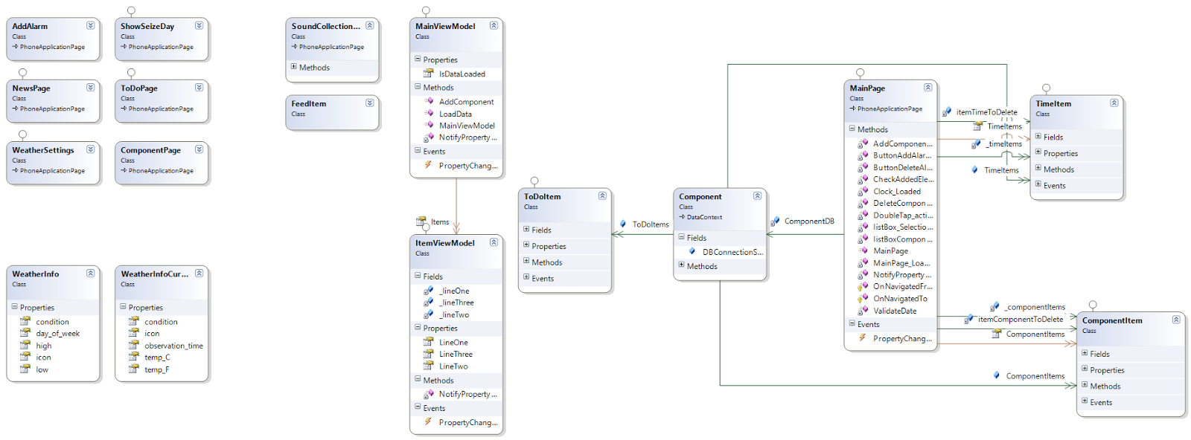



DIFFERENCES BETWEEN PROJECTS

|  |  |
| --- | --- |
| Windows Phone | Android |
|  |  |
| First screen of application. Page is blank. You can add alarm and components. | |

|  |  |
| --- | --- |
| Windows Phone | Android |
|  |  |
|  | |



Page with settings for alarm clock. You can set time for alarm here and but you can’t choose sound of alarm, like in windows phone version.

Page with settings for alarm clock. You can set time for alarm here and choose sound of alarm.

|  |  |
| --- | --- |
| Windows Phone | Android |
|  |  |
|  | |



In android version screen of choose exact time is on one page.

Screen of setting exact time of alarm.

|  |  |
| --- | --- |
| Windows Phone | Android |
|  |  |
|  | |





Screen which is shown when you want to add component. Possible components are: Weather, Aphorism, News and List of task to do.

Each component apart from Aphorism has its own page with settings.

|  |  |
| --- | --- |
| Windows Phone | Android |
|  |  |

Options for News component.

|  |  |
| --- | --- |
| Windows Phone | Android |
|  |  |

Settings for List of task component. You can add some tasks to do.  
After pressing on task item, user is moves to page, where can delete current task.

Settings for List of task component. You can add some tasks to do and use checkboxes to set them as done.

|  |  |
| --- | --- |
| Windows Phone | Android |
|  |  |

Not yet implemented

Options for weather component. As far we managed to implement manual setting of localization.

|  |  |
| --- | --- |
| Windows Phone | Android |
|  |  |

Screen displaying alarm set and added components. With double-click you can edit component..

|  |  |
| --- | --- |
| Windows Phone | Android |
|  |  |

# DIAGRAM CLASS WINDOWS PHONE

Final screen which is displayed when alarm rings. Components are displayed in a list.



# DIAGRAM CLASS ANDROID

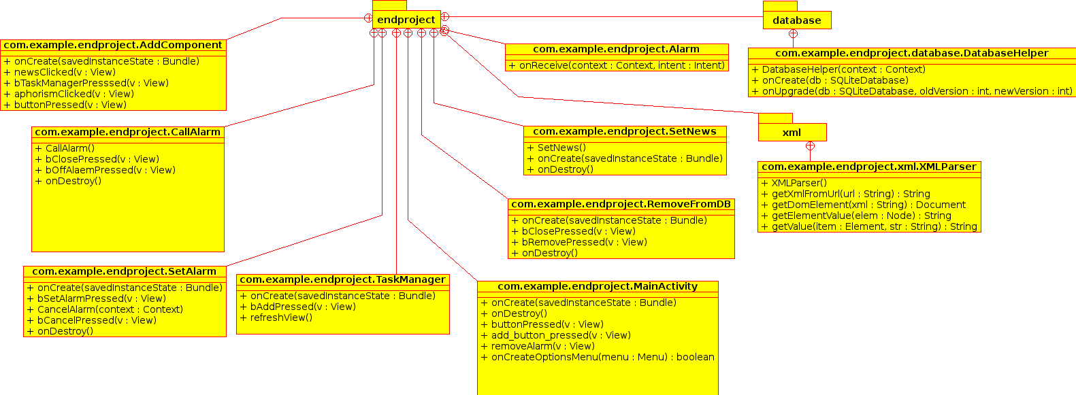



EXTRAS

# C:\Users\Michał\Desktop\black.jpgLog history on Git repository.

Commits for Windows Phone:

<http://80.51.13.3/git/?p=studia/semestr7/Windows+Phone+Programming/endProject;a=summary>

Commits for Android:

<http://80.51.13.3/git/?p=studia/semestr7/Mobile+Programming+with+Android/endProject;a=summary>